**New corrections needed for sylc export 5-13-2013**

The following corrections listed below are intended for

Login Page: <http://seobranddev.com/sylc-corporation/>

Landing Page: <http://seobranddev.com/sylc-corporation/voiture>

Admin Panel: <http://seobranddev.com/sylc-corporation/voiture/admin>

**Admin Panel Correction:**

[**http://seobranddev.com/sylccorporation/voiture/admin**](http://seobranddev.com/sylccorporation/voiture/admin)

1

Inside the customer info page

Task1

After I submitted a lead from the landing page <http://seobranddev.com/sylc-corporation/voiture> , when I went inside the customer info page of this new customer I noticed that below the **set my photo** link there is a “order placed 5-13-2013” (as shown below)

Why is this text displayed, please remove it

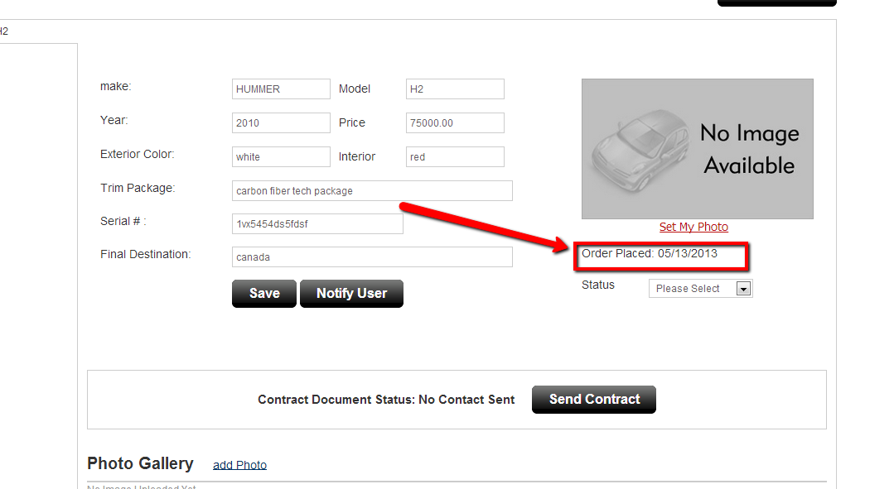

**DONE**

Task2

Error found

When I click on the **assign status** button, the pop is displayed but somehow there are statuses that are already being displayed ?!? this is a new customer ! how can there be statuses assigned already ! this is a new customer that I have just created ...please make sure that when I will click on the “assign status” button of a new customer , by default all the dropdown boxes need to be listing by default “select order”

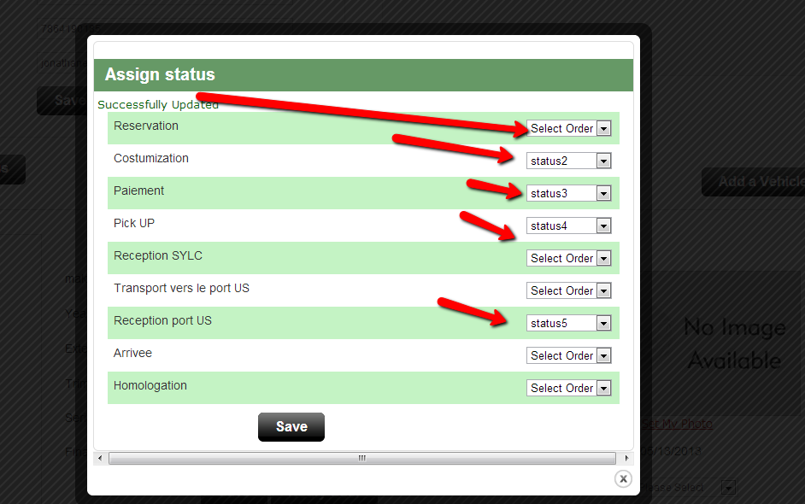

Please review my original instruction(shown below ) of how the flow of this assign status should functionality should work and the logic behind the dropdown box .

Please make sure to correct this issue and also make sure that the save button works

**Instructions of how the assign status should flow**

Modification needed to the assign status form . we need to make modification to it because currently there is no logic behind the form to prevent the admin user to assign any number to any status and present the customer with a result as shown below (in the screen shot on the right side ) as you could see the numbers are not sequential . please follow the instructions below I believe that this could be the proper solution to have this issue resolve so that we could guide the admin user so that we could prevent this.

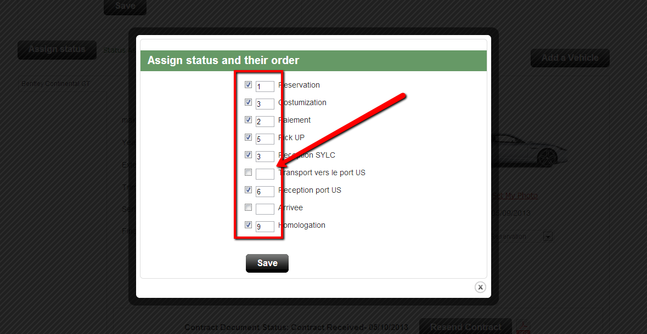 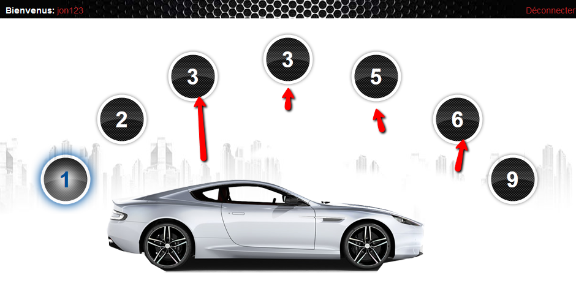

-the flow should be that when the admin user will navigate to a new customer info page , when he will click on the assign status button he should be presented with a grid similar to the one shown below in the wireframe . He will be presented with all the statuses that have been set to *active* .

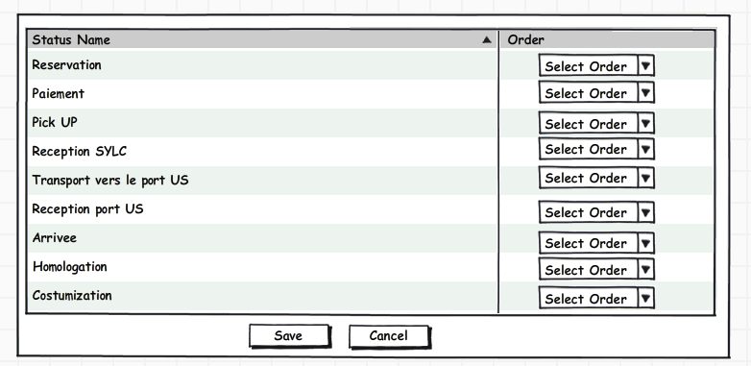

-By default the dropdown boxes should all be displaying by default the text “select status”

-when the admin user will click on any dropdown box the only other option available (besides “**select Order”)** that it is listing in that dropdown is **“Status 1”**

-after the admin has selected **“Status 1”** for any of the statuses names dropdown box that he is presented with , when he will click on his next chosen status name dropdown box, the only other option available (besides “select Order”) that it is listing in that dropdown is **“Status 2”**

-after the admin has selected **“Status 2”** for any of the statuses names dropdown box that he is presented with , when he will click on his next chosen status name dropdown box, the only other option available (besides “select Order”) that it is listing in that dropdown is **“Status 3”**

-after the admin has selected **“Status 3”** for any of the statuses names dropdown box that he is presented with , when he will click on his next chosen status name dropdown box, the only other option available (besides “select Order”) that it is listing in that dropdown is **“Status 4” and etc …….**

**Please note : regardless of the amount of statuses that are displayed depending on if they have been sent to active . please understand that even if there are 25 different statuses listed , the maximum amount that will be listed in the drop down should not exceed status 7.**

**Please note that if for example the user has assigned 4 statuses names with their status order and then the user decides to click on the dropdown of status 2 and clicks on the “select Order” and basically unselect the status 2 . then this technically means that we currently have a status order as (1,3,4). Please understand that we have to make sure that the user can not save if the order of the statuses are not sequential.**

Task3

After a contract has been submitted

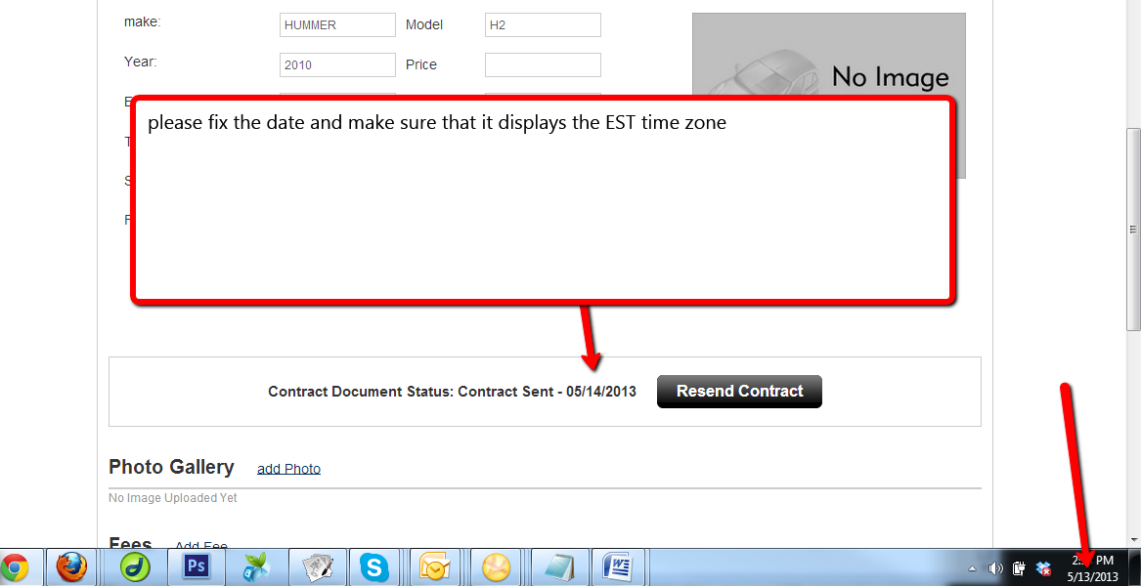

**DONE**

Task4

Please make sure that when an admin has clicked on the **send contract** button, the link that the customer will receive in his email should only be available from 48hours , after 48hours has passed from the time that the admin has submitted the contract to be signed . When the customer will click on this link after the 48hours has passed , the link should expire.

Task5

After a customer has initialed, signed and submitted back the contract, and automated email should be sent to email associated to the admin ([yoann.attia@sylc-export.com](mailto:yoann.attia@sylc-export.com) ) , please make sure that the email address [yoann.attia@sylc-export.com](mailto:yoann.attia@sylc-export.com) will be receiving the notification informing him of a customer that has signed the contract .

Please make sure that the email that the admin will receive will contain all the customers information (name , email , phone ,etc ) along with a massage saying that his customer has signed the contact .

Please display this as the title in the email “A contract has been signed ”

Task6

Error found , the save button is no longer working now!

Please make sure that when a user will click on the save button , it should save all the value in the form

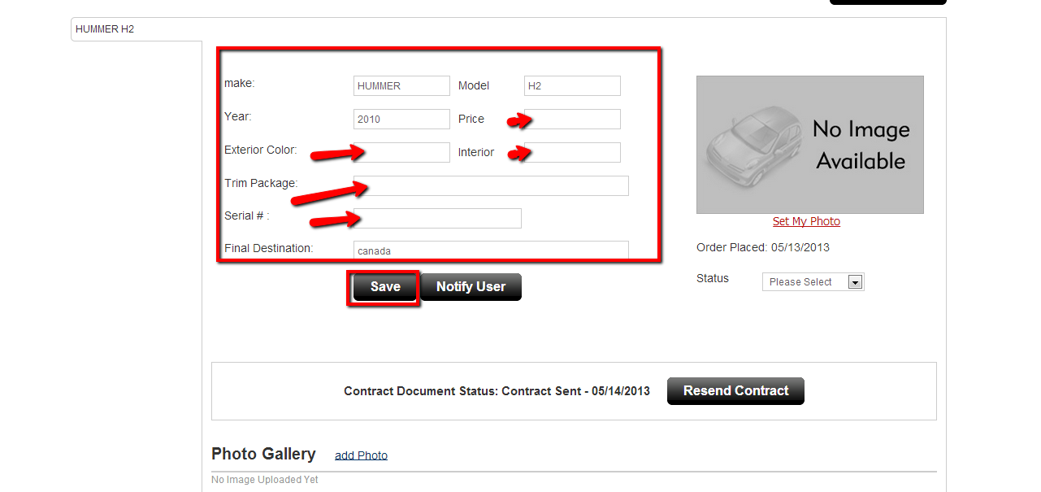

**Please make sure that the admin user is able to enter and save the form without having to select a status**

**DONE**

Task7

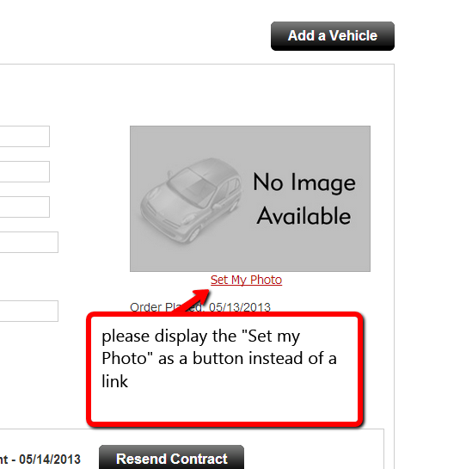

**DONE**

Task8

**This point has been marked as done and the issue has still not been fixed !!! please corrected this issue**

After I have created 11 statuses from the status manager page , I noticed that the sorting does not work correctly were I am not able to achieve the sort to view by position 1,2,3,4,6,5,7,8,9,10,11,12 instead I’m presented with 10,11,2,3,4,5,6,7,8,9 .

Please also center the pagination buttons -

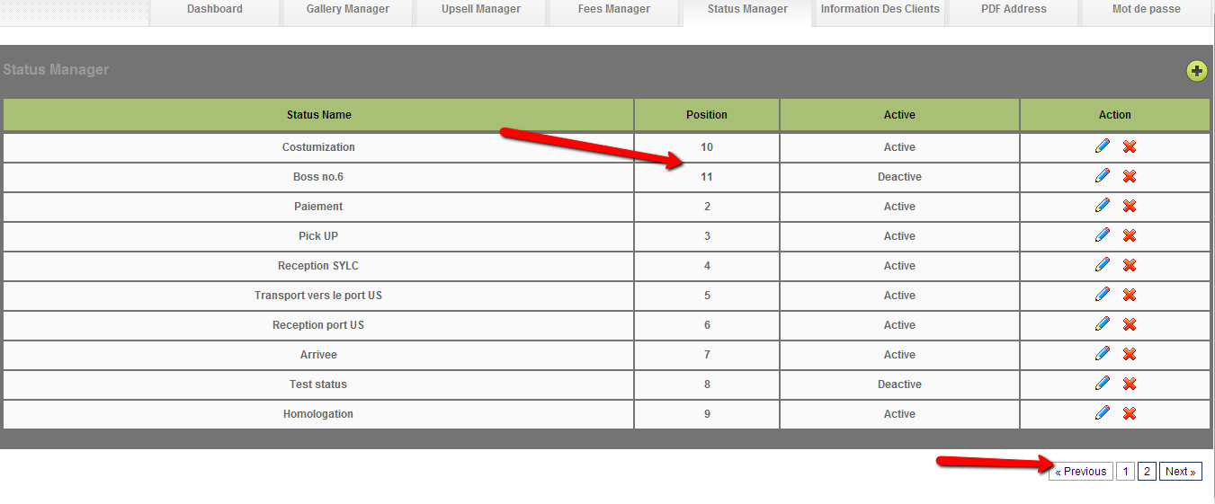

Task9

Please make this modification in the PDF file that is generated

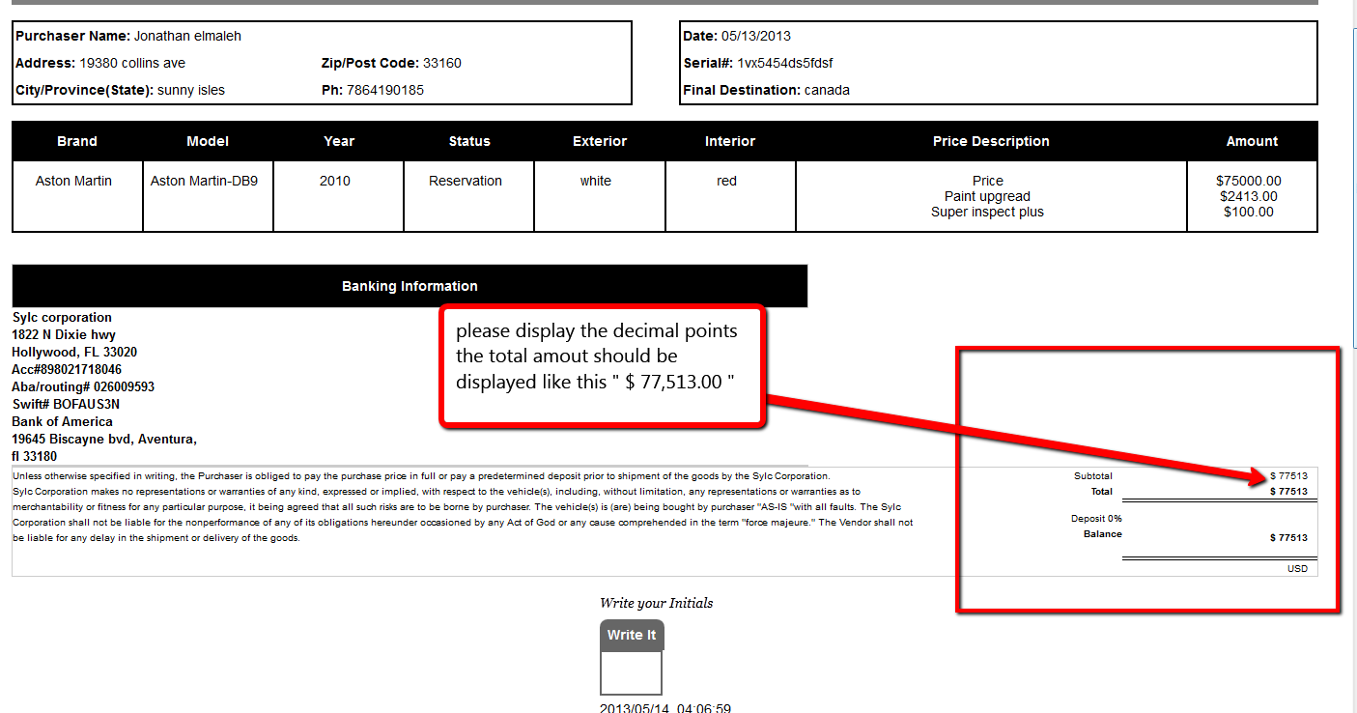

**DONE**

Task10

Please make sure to remove the vertical scrolling bar (as shown below highlighted in blue )

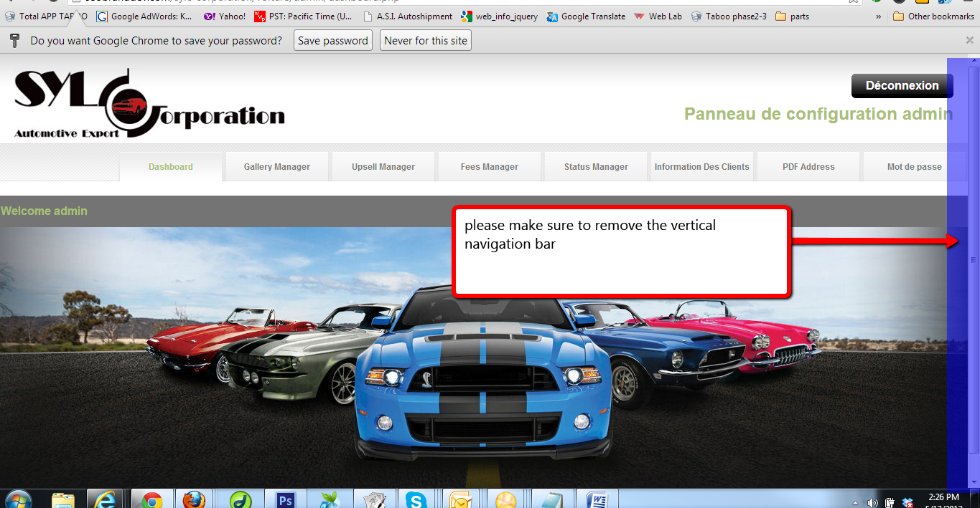

**Login Page Correction:**

[**http://seobranddev.com/sylc-corporation/**](http://seobranddev.com/sylc-corporation/)

jona123/ jona123

1

Make the following modification in the up sell pop up

**Task1**

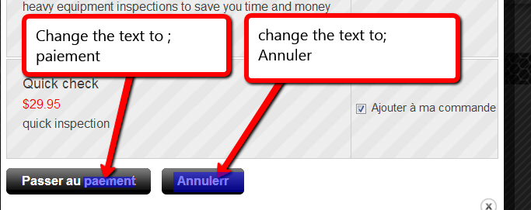

**DONE**

**Task2**

Please center these two buttons

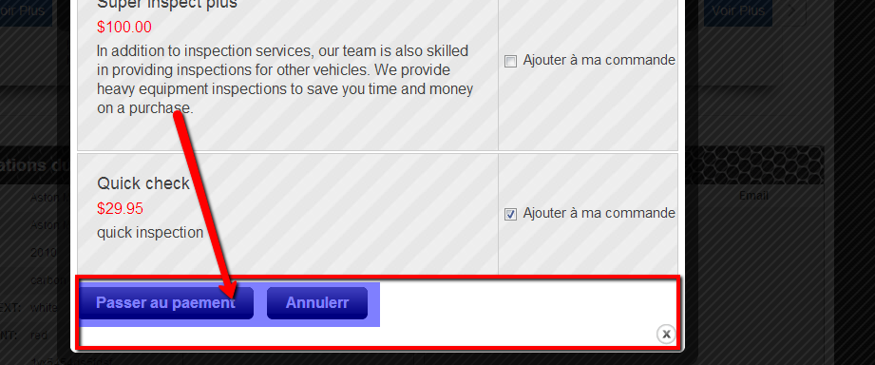

**DONE**

2

Please make sure that there is a border displayed around the areas highlighted in blue in the picture below. the border should be displayed as it is current is in the area circled in red .

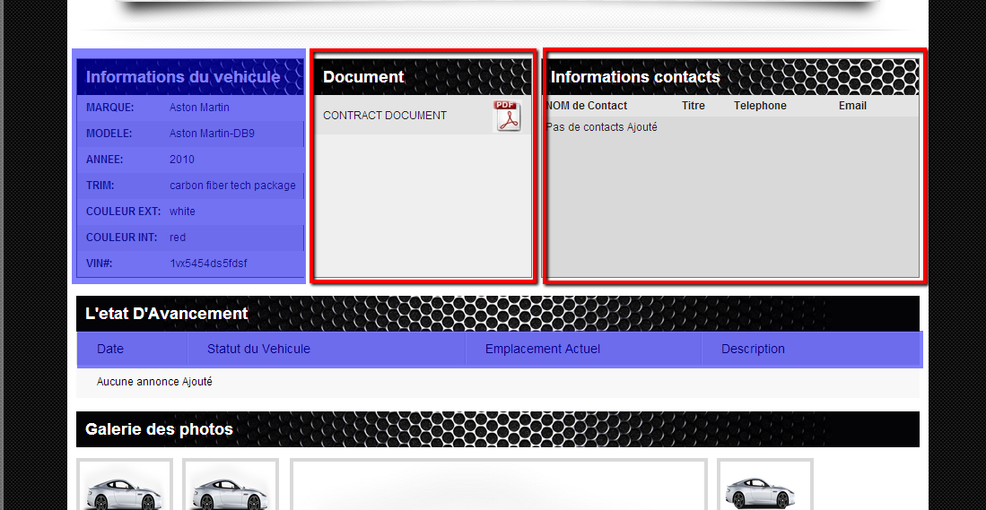

3

Please make the following modification to the upsell payment process

Task1

when I try to submit the form , I keep receiving error messages to enter valid information in the textbox , the issue is due to the validation script that doesn’t allow spaces . but what is the users first name is “jean marc” we need to make sure that the form can allow a space as long as the textbox contains more than only the space character

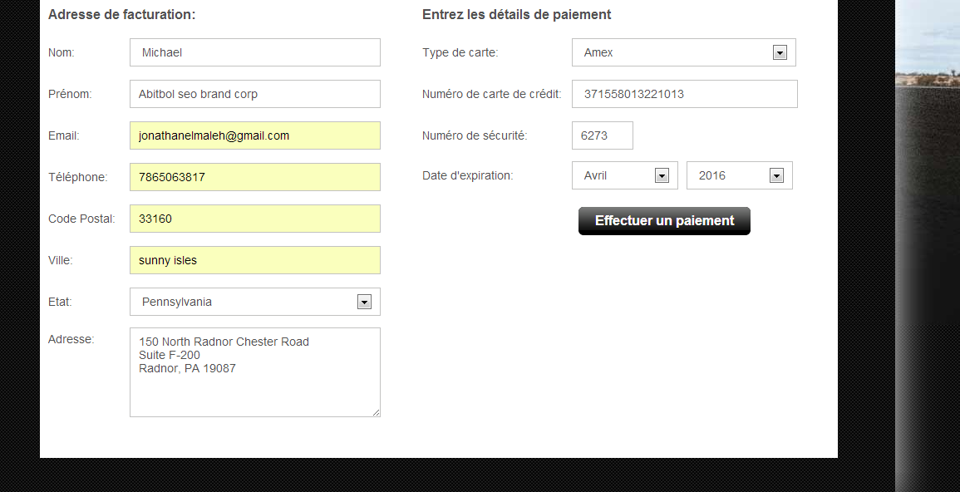

Task2

Please fix the text found in the error message

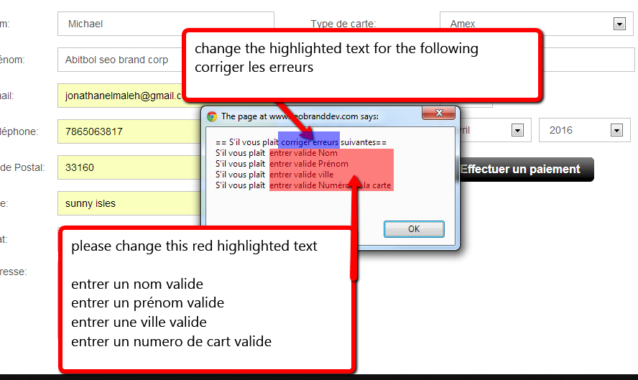

Task3

After I have completed the payment process for purchasing an up sell I realized that I have been redirected to this page (shown below )

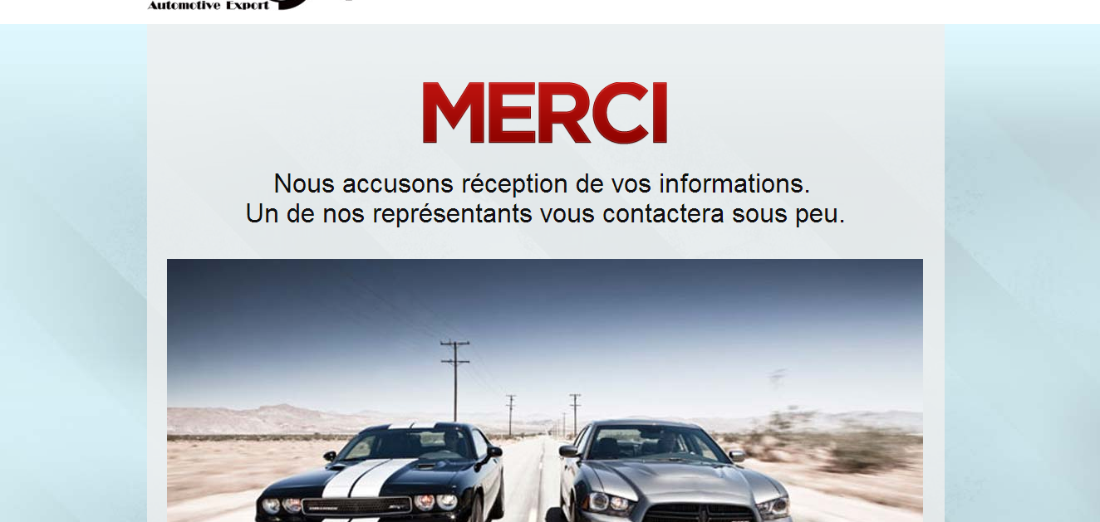

Please make the following correction, when the user will click on the **Effectuer un payment** button , he should not be redirected to this thank you page . Instead , the user should still be redirected back to his dashboard page presenting him with a pop up

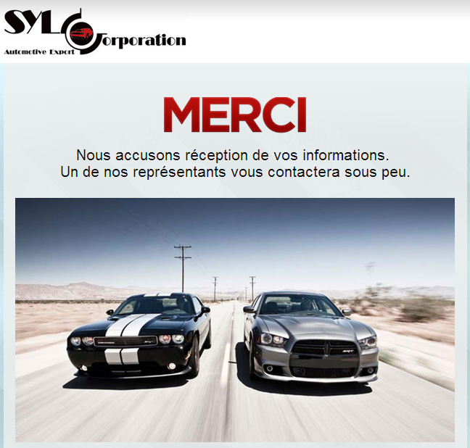

Please make sure to replace the text (highlighted below ) with the following text instead **“ Nous vous remercions pour votre achat”**

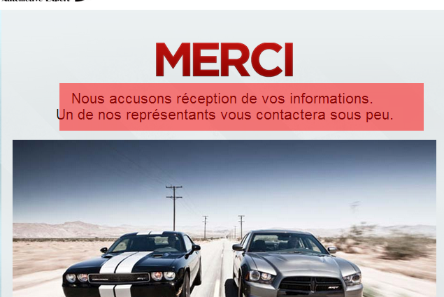

Task4

After performing a successful transaction , I noticed that the ship to information displayed in paypal does not look correct.

As you can see in the screen shot below inside the ship to information

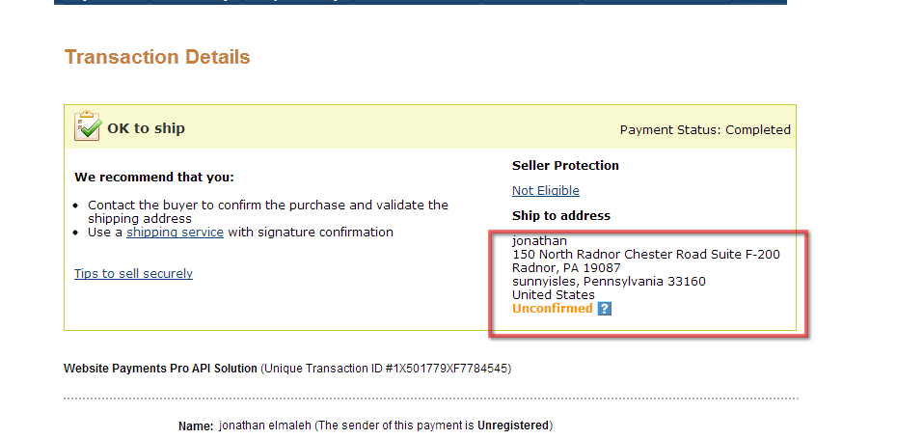

I believe that this is due to the fact the address in the payment process form is a message box and not a textbox

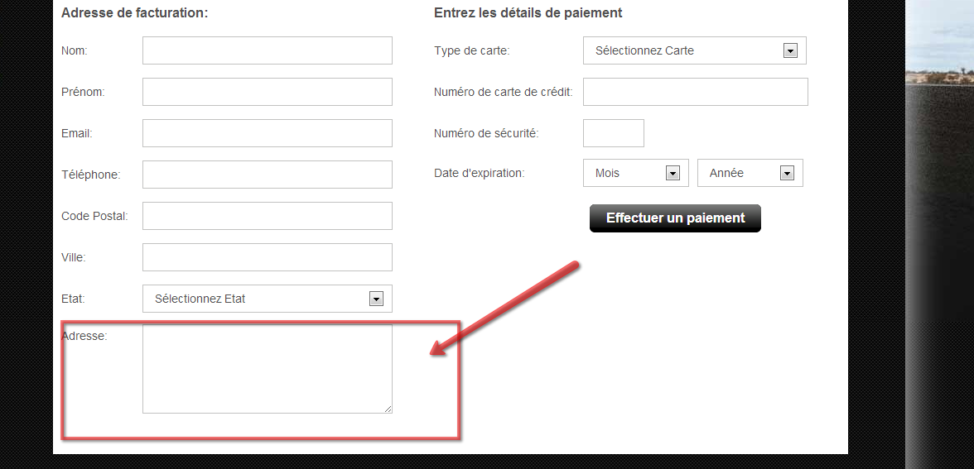

* Please change the address message box and convert it into a textbox instead .
* Please display the form in this order from now on
  + Nom:
  + Prénom:
  + Email:
  + Téléphone:
  + Adresse
  + Ville:
  + Etat:
  + Code Postal: